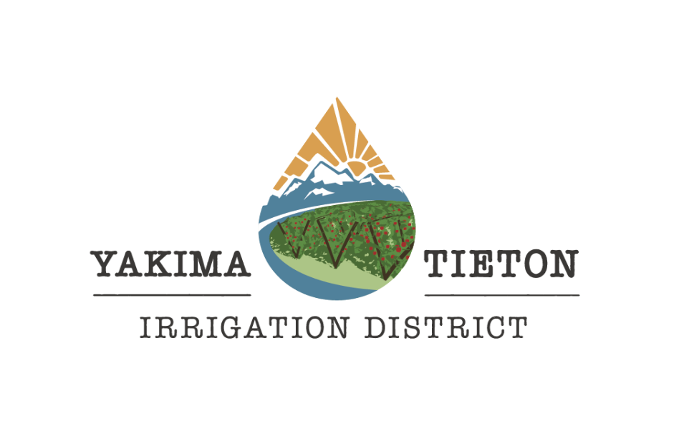

Yakima-Tieton Irrigation District is currently accepting applications for:

**Secretary-Manager-Treasurer**

**$120,000-160,000 DOQ**

Plus health, vision, dental and prescription insurance, short term disability, life and accidental death and personal loss coverage, vacation and sick leave, 11 paid holidays, PERS retirement and WA ST Deferred Comp eligible.

The Secretary-Manager-Treasurer is responsible for all operations of the District including planning, organizing, developing, and implementing comprehensive management actions to achieve the policy and program objectives established by the Board of Directors.

This position is responsible for the effective direction, operation, and control of the key activities of the District including irrigation operations, hydroelectric operations, financial operations, human resources, union negotiations, administration, governmental affairs and public information activities.

This position is responsible for anticipating, identifying, and presenting policy issues to the Board of Directors and ensuring policies and procedures remain within guidelines established by the Board and making updates as necessary. They must develop long-range objectives that are consistent with the mission of the District and update these objectives annually.

This position is responsible for overseeing and participating in the development and administration of the District’s budget; approving the forecast of funds needed for staffing, equipment, materials and supplies, and approving expenditures and implement budgetary adjustments as appropriate.

This position is responsible for establishing appropriate service and staffing levels within District policy; monitoring and evaluating the efficiency and effectiveness of service delivery method and allocating accordingly while also providing effective procedures to select, promote and develop employees for key activities in the District. The Secretary-Manager-Treasurer is responsible for ensuring an environment that encourages initiative and recognition of effort for all employees an establish realistic, attainable performance standards and take corrective action when standards are not met.

This position is responsible for planning, directing, and coordinating the District’s work plan through subordinate level staff; assigning projects and areas of responsibility; reviewing and evaluating work methods and procedures and meeting with management staff and field supervisors to identify and solve problems. The Secretary-Manager-Treasurer is responsible for assessing and monitoring workload, administrative and support systems, and internal reporting relationships; identifying opportunities for improvement, direct and implement changes and respond to and resolve difficult and sensitive patron inquires and complaints.

This position is responsible for providing assistance to the Board of Directors and participating on a variety of boards and committees. The Secretary-Manager-Treasurer is responsible for preparing, and presenting staff reports and other necessary correspondence; attending and participating in professional group meeting and staying informed on new trends and innovations in the field of water distribution, hydroelectric resources and other water resource activities. The Secretary-Manager-Treasurer is responsible to represent the District to outside agencies and organizations while actively participating in local, state and federal legislative efforts pertaining to District interests, including testimony, drafting language and communicating with elected officials and agency staff. The Secretary-Manager-Treasurer is also responsible for coordinating the legal affairs of the District with Legal Counsel and performing other related duties and responsibilities as required.

The ideal candidate will bring a positive attitude and an executive level of governmental leadership and communication experience. The successful candidate must possess strong organization and time management skills.

A bachelor’s degree in civil or mechanical engineering, leadership and management, water resources or other related field plus seven years progressively responsible experience including two years in a supervisory or managerial; **or** an equivalent combination of education and experience which provides knowledge, skills and abilities sufficient to successfully perform the essential duties of the job. (Note: Applicants with equivalent education and/or experience must provide a detailed explanation.)

**Required:** Washington State Driver’s License and must be able to pass a background check and a pre-employment drug and alcohol test.

**In order to be considered, all applications need to include a YTID application (found on the YTID website), resume and cover letter detailing interest and qualifications.**

**To understand the full requirements and the knowledge, skills and abilities needed for this position please visit our website at** [**www.yakimatietonirrigation.com**](http://www.yakimatietonirrigation.com) **for a full job description and application.**

Applications are being accepted until **Friday, April 28, 2023.** The Yakima-Tieton Irrigation District is an Equal Opportunity Employer